
JIH Health Care Website
[Code Review Record
Revision History
Version | Author | Date | Remarks
1.0 | Livin CJ | 28-04-2020

Project Code Review Document

Feature
Title

Review Team
Name | Reviewer Role | Scope | Time Spent

Review Details
File(s) & version(s) to be reviewed
Item | Reviewer | Filename | Line # | Issue | Resolution

RESOLUTION CODES

F – Fixed, per resolution description.
NC – No change
Dup – Duplicate issue, the item number should be put to resolution column.
Bug – The finding will be resolved through the bug/defect process. The number of the Bug/Defect and database name should be put in the resolution column.
*Sug - Suggestion
* - Error

URL : http://nikotravels.com/JIH/

1.

* Menu icon not seen in white background

2.

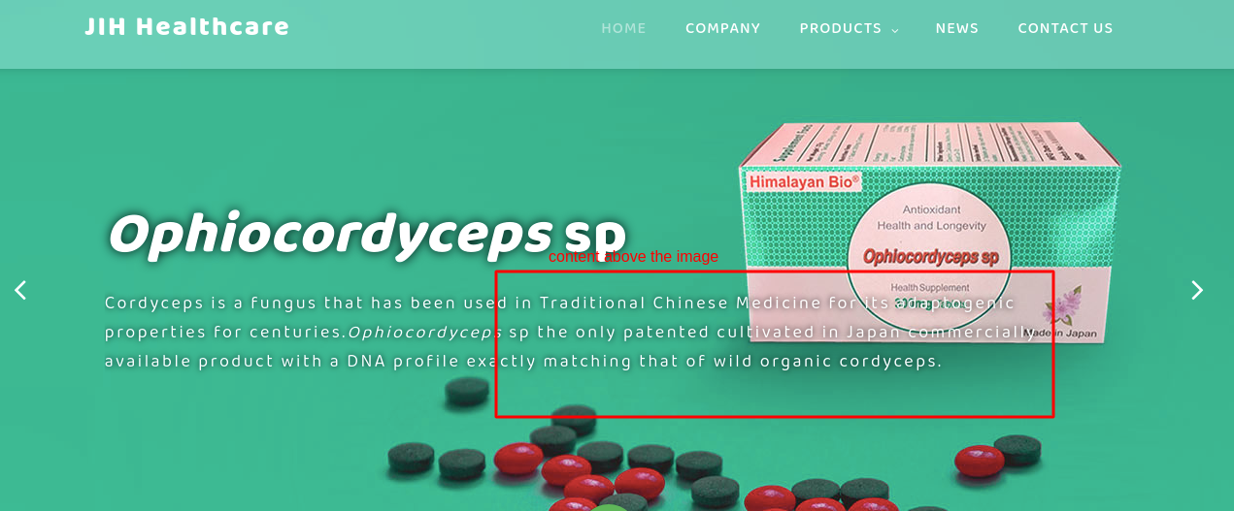

* content above image

3.
* Reduce the height of the banner in ipad (768px )

* font not view-able (font size increase)



4.

* same padding need in mobile (below 768px) (@media max-width(767px){})

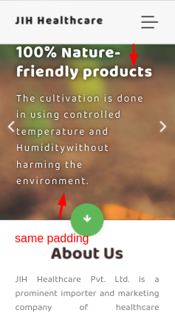

5. * Need full image image cut off (below 768px) (@media max-width(767px){})

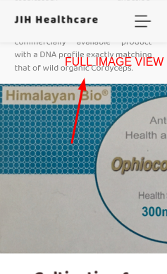

6.

* Footer – tel: tag missing (<a href = “tel:00000”>000000</a>)

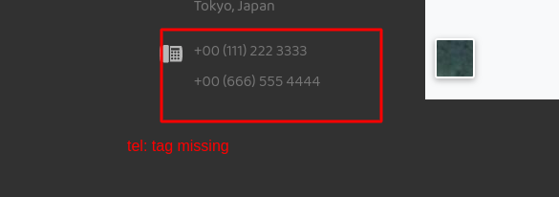
7.

* Footer – Same link on all social icons



8.

* need padding and also check the line height in mobile view (bellow 767 px)

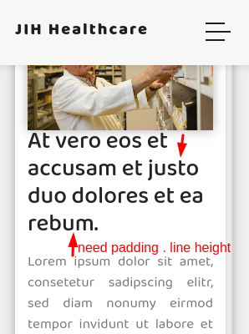

9.

* Avoid Resize the Text area – contact us

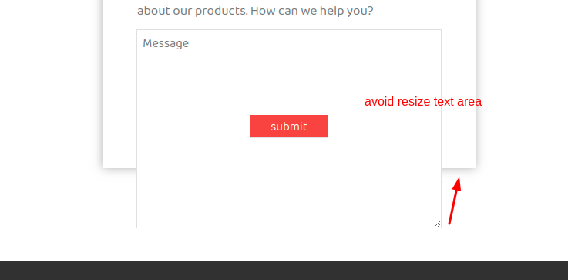

10.

* Icon above about us – position fixed while scrolling (mobile below 767 px)

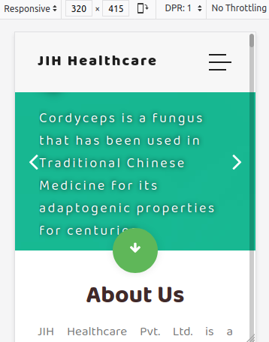

FIRE FOX WEB BROWSER

1. Banner padding and font size problem, background image cut off ( MOBILE VIEW BELOW 768px )

